Project Design Phase-II
Data Flow Diagram & User Stories

Date | 15 February 2026
Team ID | LTVIP2026TMIDS81358
Project Name | OrderOnTheGo : Your On-Demand Food Ordering Solution
Maximum Marks | 4 Marks

Data Flow Diagrams:

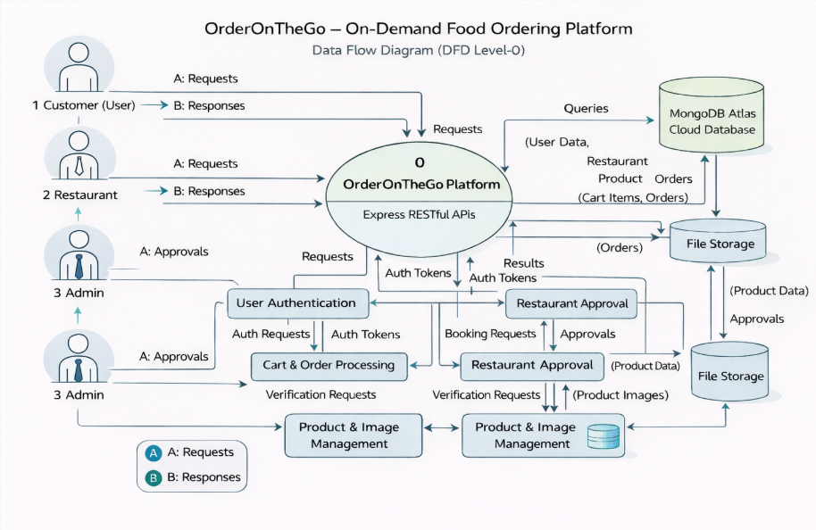
User Stories
User Type | Functional Requirement (Epic) | User Story Number | User Story / Task | Acceptance criteria | Priority | Release
Customer (Web User) | Registration | USN-1 | As a customer, I can register using email and password | Account created & dashboard accessible | High | Sprint-1
Customer (Web User) | Authentication | USN-2 | As a customer, I can log in  securely | Successful login redirects to home page | High | Sprint-1
Customer (Web User) | Restaurant Listing | USN-3 | As a customer, I can view  available restaurants and  food items | Restaurant list  loads from  database | High | Sprint-1
Customer (Web User) | Add to Cart | USN-4 | As a customer, I can add food items to cart | Items appear in cart with quantity | High | Sprint-2
Customer (Web User) | Order Placement | USN-5 | As a customer, I can place orders with address and payment method | Order status shows “Placed” | High | Sprint-2
Restaurant | Product  Manage  ment | USN-6 | As a restaurant, I can add/edit  /delete food items | Products updated in dashboard | High | Sprint-3
Administrator | Restaurant Approval | USN-7 | As an admin, I can approve  restaurant registrations | Approved restaurant visible to users | High | Sprint-3
Customer (Web User) | Notifications | USN-8 | As a customer, I receive order updates | Order confirmation displayed on dashboard | Medium | Sprint-4
Customer (Web User) | Order History | USN-9 | As a customer, I can view  previous orders | Order history visible in profile | Medium | Sprint-5

